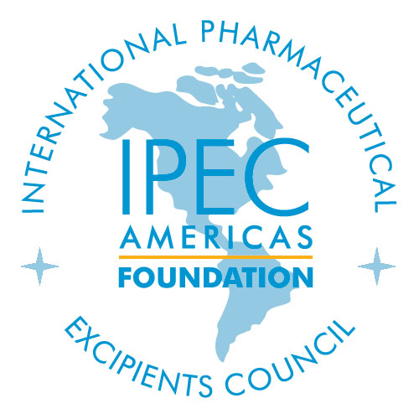
The Patrick DeLuca
Emerging Researcher Award

The IPEC Emerging Researcher Award will be presented each year to a beginning career scientist post Ph.D. i.e., postdoctoral fellows, research assistant professors and early stage of an assistant professors (1 -2 years following initial appointment as research assistant or assistant professor). Applicants are encouraged from any part of the globe.

The award criteria include: demonstrated interest in and dedication to the area of excipients in terms of: published manuscripts and a research proposal in the area of excipient scientific/technological research.

Nomination Requirements/Package

- The research proposal should be no more than four pages in length (12 pt. font) including most relevant references and should emphasize the relevance to excipients.

- The proposal should also include a brief plan of what the applicant hopes to achieve by the end of the first and second years of the project.

- A copy of the applicant’s Curriculum Vitae and two letters of recommendation must be attached to the application.

- The award (in the amount of $15,000 per year) will be for up to two years, with the second year of funding contingent upon adequate progress during the first year. The funding associated with this award will be provided to your institution and must be spent on supporting your research proposal (chemicals and supplies, equipment, student support etc. a maximum of $2,000 per year on travel to attend the AAPS annual meeting) A budget should be provided at the time of the application. No part of this award should be used for indirect costs or other institutional expenses.

- A progress report of up to ten pages must be submitted at least one month prior to the end of the first year of funding. Second year applicants must demonstrate progress with at least one abstract and/or one manuscript submitted.

- The successful applicant/nominee must attend the AAPS Annual Meeting and Exposition in both years of the award and must make a presentation in the second year on progress made. Failure to attend the meeting will result in forfeiting the award funds.

- One research or review manuscript should be submitted to the International Journal of Pharmaceutical Excipients by the end of each year of the award.

- Nomination form and all supporting materials should be sent as a single pdf file to ipecamer@ipecamericas.org

- The award title must be included in the subject line.

Both the abstract submission and nomination submission deadlines are June 15.

Selection Procedures
The applications will be reviewed by a Selection Committee chaired by the Vice Chair of the IPEC-Americas Foundation. The Selection Committee will also review progress at the end of the first year of the work to determine the suitability of the project for continuation to the second year of funding.

Emerging Researcher

Nomination Form
- Nominee Information

Name__________________________________________________________________________________

Organization/Institution____________________________________________________________________

Address________________________________________________________________________________

City_________________________________________ State ________________ Zip Code _____________

Country _______________________________________ Email ___________________________________

Telephone ___________________ Fax __________________ Abstract Submission ID #_______________
Please provide Country Code if outside the United States

______________________________________________ ________________________________________
Signature of Nominee Date

Professor/Advisor Information

Name__________________________________________________________________________________

Organization/Institution____________________________________________________________________

Address________________________________________________________________________________

City_________________________________________ State ________________ Zip Code _____________

Country ______________________________________ E-Mail ___________________________________

Daytime Telephone______________________________Fax______________________________________
Please provide Country Code if outside the United States

______________________________________________ _______________________________________
Advisor Signature Date
Submit all applications in a single pdf file to: ipecamer@ipecamericas.org by June 15.

